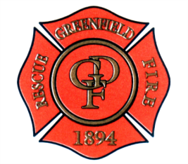

GREENFIELD FIRE TERRITORY

Chief Brian D Lott
17 W. South ST, Greenfield IN (317) 477-4430

Now Hiring
Firefighter / Paramedic
Firefighter / EMT
Lateral Transfers Welcome

The Greenfield Fire Territory is now accepting applications for the position of Career Firefighter EMT / Paramedic. All applicants must be United States Citizens or be authorized to work in the United States, Twenty-one years of age, have a high school diploma or equivalent and a valid driver's license and meet the additional specific requirements set forth by the Greenfield Fire Territory.

The Greenfield Fire Territory staffs 2 stations with 49 personnel that responded to 4761 calls for service in 2021. The department has a Fire Training Center, Technical Rescue Team, SWAT Medics, Quartermaster system, on site wellness centers and operates with a family atmosphere setting.

The City of Greenfield offers our full time Fire Fighter/EMT personnel a benefit package which consists of:

- Starting Salary of $56,515 Plus $4000 Paramedic Stipend
  - (Lateral transfers salary is dependent on years of service and experience)
  - Holiday Pay for Major Holidays
  - $3000 Longivety Pay with a total Pension Base at $68,247
  - 1977 PERF Pension
- Full Kelly Day on a 28 day FLSA Period
- Low Cost Health, Dental, Vision
- $25,000 Life Insurance at no cost.
- Up to 5 PTO days a year as well as annual vacation pay after one year of employment.
- Access to a 457 plan, ID shield, legal shield, and other supplemental insurance packages.
Apply at the FirefighterApp site:
https://www.PoliceApp.com/GreenfieldFireIN.

