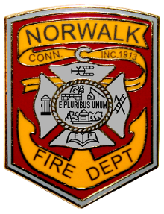
Norwalk Fire Department- Firefighter test and hiring process
Town Hall Meeting via Zoom
Wednesday, April 21-6:30p-8:30 pm
Agenda
- Welcome and Introductions
- About the City of Norwalk and the Norwalk Fire Department
- Testing process (Written test- May 22 and oral interviews)
- Candidate Physical Ability Test (CPAT)
- CT Fire Academy
- Probation period
- A Day in the Life of a Firefighter
- Question and Answer/ Wrap Up

The link for the public to attend in zoom and submit any questions during the webinar is
https://us02web.zoom.us/j/86575473268
View only on YouTube: City of Norwalk Connecticut - YouTube (cannot submit questions)

