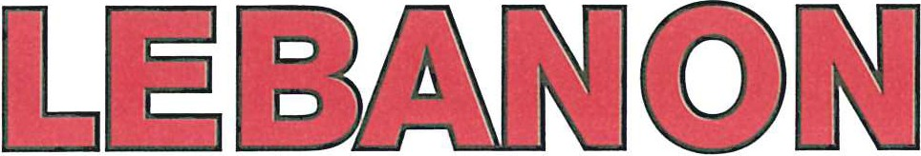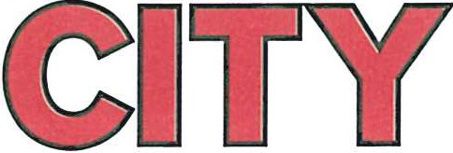

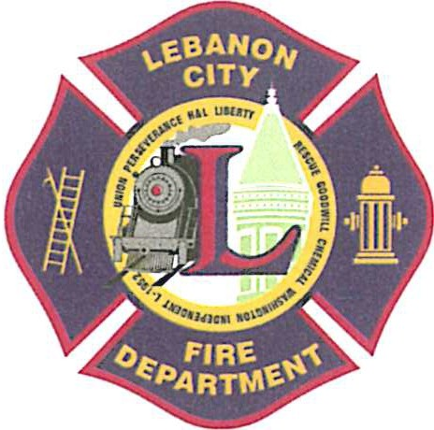
735 Cumberland Street Lebanon, PA 17042
(717) 639-2800
This form must be completed before participating in a job related Physical Performance Test.

I hereby certify that _____________________________, is an applicant for the Civil Service position of Career Firefighter with the City of Lebanon Fire Department, and has consulted me with regards to him/her participating in a job related Physical Performance Test conducted by the City of Lebanon. I understand that this test may be strenuous, but is required to ascertain the applicant’s ability to perform job related fire services duties. By signing this form I hereby state that I have determined that he/she is physically capable of undertaking such test.

Date Signature
(M.D., D.O., P.A.C. or C.R.N.P)

Sherry L. Capello
Mayor

Aaron. Sweitzer
Deputy Fire Chief

Union Steam Fire Engine
& Hose Co. No. 1

Perseverance Fire Co.

Lebanon Hook & Ladder Co. No. 1

Liberty Steam Fire Engine
& Hose Co. No. 3 Rescue Hose Co. No. 4
Goodwill Fire Engine
& Hose Co. No. 5

Chemical Engine &
Insurance Patrol Co. No. 1 Washington Fire Co. No. 8 Independent Fire Co.
Lebanon City Fire Police L-1952, I.A.F.F.
FIRE DEPARTMENT
MEDICAL CLEARANCE

